(AUTONOMOUS)
Accredited by NAAC with Grade ‘A’ (CGPA Score 3.41 on a 4 Point Scale in 3rd Cycle)
Best Affiliated College – Goa University Silver Jubilee Year Award
Gogol, Margao, Goa – 403602

Centre for Teaching and Learning

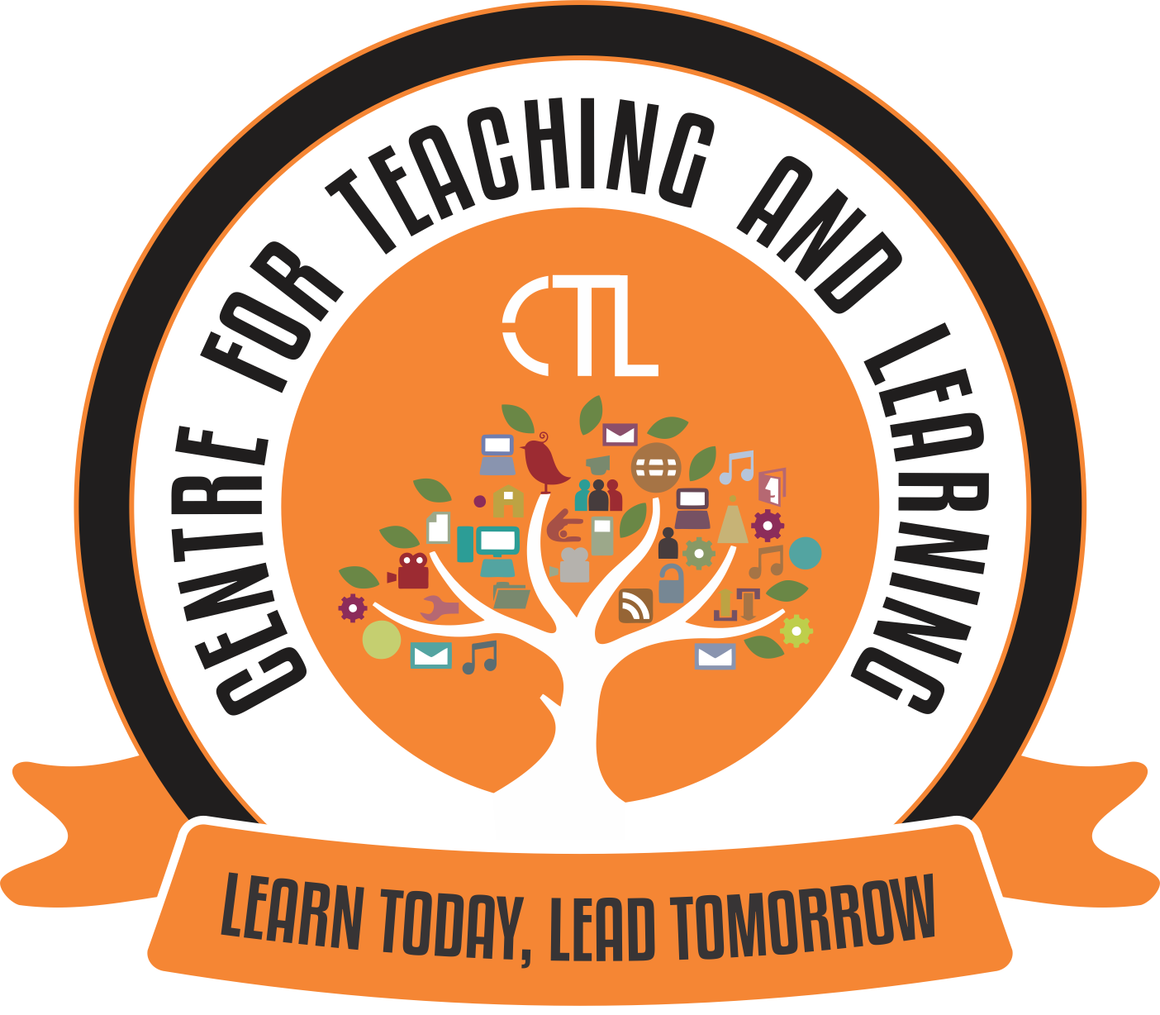

Vision

To contribute towards the growth and advancement of teaching and learning of faculty and students, through the process of training faculty with new technologies, integrating them and involving students in the whole process of learning, thus heading to mould the new generation as lifelong learners.

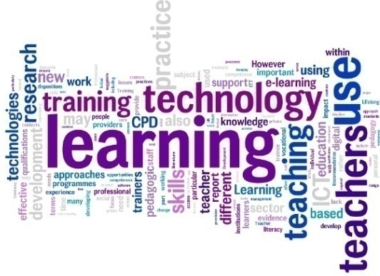
Mission

To continue to enhance the knowledge among the faculty to learn, blend and teach significantly with the fast paced dynamically changing technology world. This centre would offer useful inputs for learning, teaching and sharing information, experience and knowledge with the relevant community.

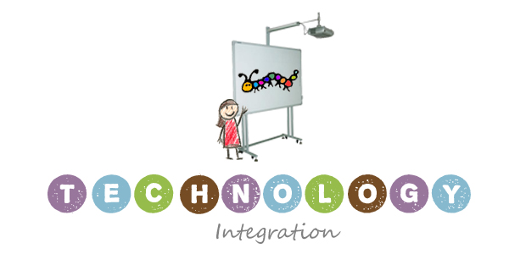

About The College

Chowgule College has been a pioneer in the State of Goa not only by introducing a first course in Computer Education in the year 1996 but also in initiating E-learning in the state of Goa in 2007 with its ICT enabled classrooms, Wi-Fi campus, online admissions and use of a Learning Management System (LMS) in the teaching-learning process. The college has well equipped computer laboratories and a separate department called Office of Information Technology (OIT) that takes care of all IT related services required by the college.

Introduction CTL

The last decade has witnessed dramatic increase in technology incorporated into tertiary education. Students are heavily immersed in Web 2.0 technologies, with ICT (Information Communications Technology) playing an increasingly important role in student life providing countless options for learning. This has definitely impacted the teaching learning process in and outside the classrooms. Economic pressures and new models of education are bringing unprecedented competition to the traditional models of Higher Education among the faculty.

Many challenges impacting technology uptake are grounded in everyday realities that often make it difficult for the teaching faculty to learn, adopt, new tools and approaches. There is also lack of support and no appropriate resource channels through which the faculty can address their issues and hope for help. With this backdrop and keeping in mind the current scenario of Higher Education in India and the challenges that we are likely to face in the quest for remapping and revitalization Higher Education and competing with world class Universities, CTL is the need the hour and will benefit all stakeholders.

The infrastructure for the centre has been partly funded by RUSA (Rashtriya Uchchatar Shiksha Abhiyan)
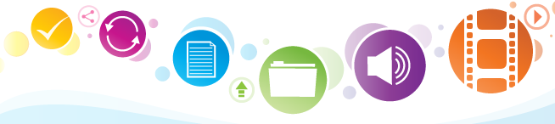

Objectives

The main objective of setting up of the Centre for Teaching and Learning (CTL) is to:
1. Educate faculty on how to go about integrating ICT in Higher Education effectively by conducting workshops, seminars and provide them with hands-on experience/training.
2. Develop E-content for the various courses offered by the college and other educational institutions.
3. Innovate, Implement and Share different ICT tools in teaching like Simulation, Gamification, LMS, Mobile Applications, etc.
4. Conduct Research related to use of ICT, Learning Analytics, Mobiles, LMS, etc.
5. Provide Consultancy services to schools and other Higher Educational Institutions by providing a roadmap for ICT implementation
6. Provide Assessment/evaluation strategies to track student progression to graduation.

Services offered by the Centre

- Provide Training and support through the conduct of programmes and workshops (ICT tools) – Science, Language and Social Sciences, (Simulations, FOSS, LMS, Gamification, Mobile applications etc.)
- Develop and Design Evaluation and Assessments Techniques/ Methods.
- Conduct Research that involves studies relating to the Effectiveness of various ICT Tools in Education, Teaching-Learning, Methodologies, Surveys, Learning Analytics etc.
- Provide Educational opportunity for faculty which includes funding opportunities, collaborations/exchange programmes.
- Provide support, consulting and assistance related to Curriculum Design, Development and Innovation.
- Development of E – Content
- Assist in development and delivery of Open Online courses / Distance programmes / MOOCs.
- Provide Consultancy Services comprising roadmap for ICT implementations, SWOT analysis, framing Vision and Mission statements, ICT related projects (software development, websites etc.) and Accreditation (NAAC, etc.)
Contact Details:

Centre Director:
Dr. (Ms). Sameena Fernandes e Falleiro
Associate Professor - Department of Computer Science

Contact Email: ctl@chowgules.ac.in
Website: http://www.chowgules.ac.in/ctl
Phone: 0832 2759504, 2759231

